- Bluebook Page113 August 2019 variant three examination:

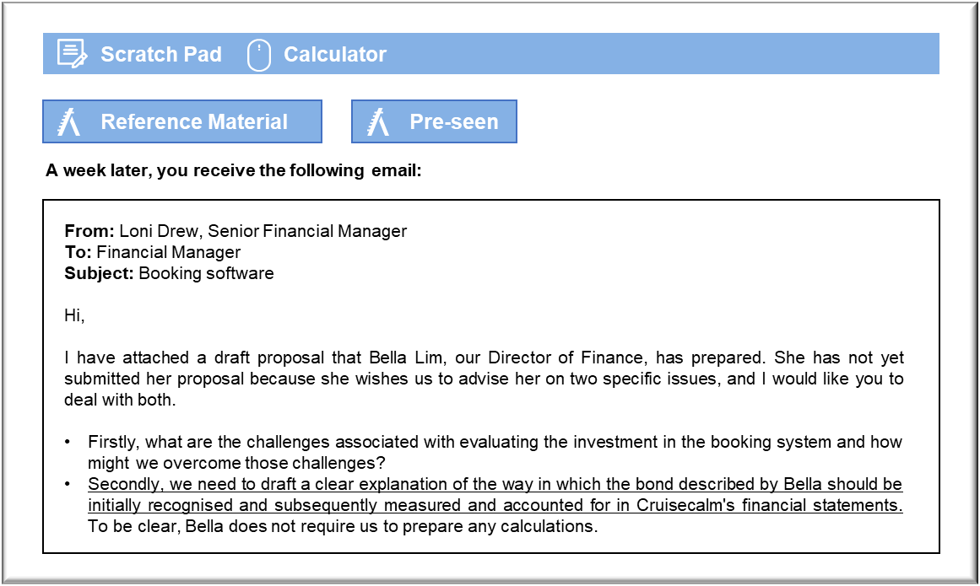MANAGEMENT CASE STUDY AUGUST 2019 EXAM ANSWERS

Variant3 Task2
These answers have been provided by CIMA for information purposes only. The answers created are indicative of a response that could be given by a good candidate. They are not to be considered exhaustive, and other appropriate relevant responses would receive credit.

CIMA will not accept challenges to these answers on the basis of academic judgement.

Requirement 1: Evaluating investment
The most immediate challenge with any investment in information systems is that the projected cash flows are difficult to predict with any certainty. We know that there is a potential gain, but that may not be sufficient to justify the significant outlay. We do not know what benefits we will receive until the system is in place and we can compare the actual results with historical bookings. We hope that giving potential passengers reliable and accurate prices for cruises will increase our sales, but we do not know the extent to which that will happen. A new system will require a significant outlay and we do not necessarily know the extent to which overpricing is a relevant factor in the loss of bookings.
The second challenge is that the Board must have a clearer indication of the relevant options
that are available. The Director of Finance has presented this as a choice between operating
with a flawed booking system and spending N$80 million on a completely new system. Given
that the flawed booking system is unreliable and appears to be costing revenue, the Board will have little choice but to invest in the new package if that is the only alternative under
consideration. There could be more cost-effective responses to the problems with the booking system, though, which would save both time and money. The solution proposed by the Director of Finance appears to offer very little in the way of added value, other than the urgently needed correction of the mispricing.
The first challenge might be overcome by conducting an exercise to quantify the extent of the mispricing under the existing system and the extent to which the errors are affecting bookings. Cruisecalm could have sales staff analyse a number of dropped bookings and have them calculate the correct quote manually. If the quoted price is overstated by a very small percentage then it is unlikely to have caused the customer to quit. These customers have already input their contact details, so it would be possible for Cruisecalm to contact them and offer then the same cruise with the correct price. The customers’ responses to such corrected quotes will help determine whether the investment in a more reliable booking system might improve revenues. If there are very few sales on the basis of corrected quotes then there is little point in buying the package.
Cruisecalm’s sales and systems staff should investigate whether the system does have to be
replaced in its entirety. Booking systems are designed to be updated for changing prices and so the Director of Finance’s belief that it has been updated too often may prove unfounded.
Analysing the incorrect quotes might make it relatively easy to establish which part of the system requires an update and so it may then be possible to correct the errors. It should also be possible to look back to establish whether the start of the dropped bookings coincided with an update or upgrade, which would help to narrow down the change that ought to be investigated. In evaluating the revenues from the purchase of the new system, it should be borne in mind that there might be a high risk that any new system will contain errors, even if it is a standard package.

Requirement 2: Bond
The treatment of the bond is set out in IAS 32 Financial Instruments: Presentation. The bond is a financial instrument that falls within the scope of the IAS and is not subject to any of the
exclusions. The bond is a financial liability because it imposes a contractual obligation to deliver cash to another entity.
The cost of the bond should be determined in relation to the discount against face value at the time of issue. The bond will be worth N$280 million at the time of redemption, but the buyers will pay only N$200 million at the time of issue. The N$80 million discount will be recognised as a finance charge on an accruals basis over the five-year life of the bond.
IAS 32 will require Cruisecalm to recognise a liability of N$200 million at the issue date of the
bond, which is clearly the economic substance of the arrangement. There will be an annual
interest charge that will be determined as the rate of compound interest that will increase the August 2019 4 Management Case Study Exam
N$200 million to N$280 million over five years. The annual interest will be recognised as a finance charge in Cruisecalm’s statement of profit or loss.
The annual interest charge will not be paid to the bond holders, so it will have the effect of
increasing the value of the non-current liability in the statement of financial position. The liability will be transferred to current liabilities when the bond’s repayment date falls within one year. It will be settled by a cash payment at the end of year five.e.

